**Cryptography with Information Theory**

**DSN4091 - CAPSTONE PROJECT PHASE-I**

**Phase – I Report**

***Submitted by***

**Name Reg.No**

**Karan Kumar Chauhan 21BCE10243**

**Abhishek Kumar 21BCE10084**

**Deep Radadiya 21BCE11343**

**Vikash Kumar Sinha 21BCE11500**

**Amul Gupta 21BCE11606**

***in partial fulfillment of the requirements for the degree of***

***Bachelor of Engineering and Technology***



**VIT Bhopal University**

**Bhopal**

**Madhya Pradesh**

**April, 2025**



**Bonafide Certificate**

Certified that this project report titled **Cryptography with Information Theory** is the bonafide work of **21BCE10243 Karan Kumar Chauhan; 21BCE10084 Abhishek Kumar; 21BCE11343 Deep Radadiya; 21BCE11500 Vikash Kumar Sinha; 21BCE11606 Amul Gupta** have carried out the project work under my supervision.

This project report (DSN4091 - Capstone Project Phase-I) is submitted for the Project Viva-Voce examination held between 23rd September – 29th September 2024.

**Supervisor**

**Dr. Mohammad Sultan Alam**

**Assistant Professor**

**School of Computer Science and Engineering**

**VIT BHOPAL UNIVERSITY**

**Content**

|  |  |  |
| --- | --- | --- |
| **S.No** | **Topic** | **Pg.No** |
| 1 | Introduction  1.1 Motivation  1.2 Objective | 3-4  3  4 |
| 2 | Existing Work | 5 |
| 3 | FrontEnd, BackEnd and System Requirement | 6-8 |
| 4 | Methodology  4.1 System Design/Architecture  4.2 Working Principle  4.3 Result and Discussion | 9-12  9-11  11  12 |
| 5 | Appendix | 13-18 |
| 6 | Individual Contribution | 19 |
| 7 | Conclusion | 20 |
| 8 | References and Publications | 21-22 |

# CHAPTER 1: INTRODUCTION

As the world becomes increasingly interconnected through digital platforms, the security of transmitted and stored information has emerged as a critical concern. Cryptography, the science of encoding and decoding data to protect it from unauthorized access, plays a vital role in maintaining the privacy, integrity, and authenticity of digital communications.

One of the cornerstones of cryptographic security is the unpredictability of encryption keys. If the keys used in cryptographic systems are predictable or poorly generated, they become vulnerable to various forms of attack, including brute-force and statistical analysis. To evaluate the strength of these keys, concepts from Information Theory, particularly Shannon entropy, are used to measure the amount of uncertainty or randomness within a system.

This project focuses on examining how entropy contributes to the strength of cryptographic algorithms. By comparing both symmetric and asymmetric encryption methods, such as AES, DES, 3DES, Blowfish, RSA, DSA, and ECC, this study aims to explore their randomness characteristics and the role entropy plays in securing data. Special attention is given to the entropy per byte and how it correlates with the effectiveness of each algorithm under different scenarios.

In doing so, this research provides an early insight into how entropy-based evaluation can guide the selection of encryption techniques for various applications. It sets the groundwork for understanding more complex cryptographic evaluations by linking foundational principles from information theory with real-world security practices.

## 1.1 Motivation

With the rapid expansion of digital infrastructure and the growing reliance on interconnected systems, protecting sensitive information from cyber threats has become increasingly critical. Cryptographic techniques are central to achieving this protection, and at the heart of these systems lies the process of key generation. The effectiveness of an encryption algorithm depends heavily on the unpredictability and randomness of the keys it uses.

A core concept from information theory is entropy. It serves as a valuable tool in evaluating the strength of these cryptographic keys. Entropy measures the uncertainty or randomness within a system, and in the context of cryptography, higher entropy implies keys that are more resistant to various forms of attack. Weak key generation with low entropy can lead to predictable patterns, making encrypted data more susceptible to compromise.

This study is driven by the need to understand how widely adopted encryption algorithms perform in terms of key entropy. By comparing symmetric and asymmetric algorithms like AES, DES, 3DES, Blowfish, RSA, DSA, and ECC, this research explores the relationship between entropy, key strength, and system performance. The goal is to highlight the importance of entropy in the selection and application of cryptographic methods, especially as attackers gain access to more powerful computational tools.

## 1.2 Objective

The primary objective of this research is to analyze and compare the entropy levels and key generation mechanisms of widely used symmetric and asymmetric cryptographic algorithms. Specifically, this study aims to:

1. **Evaluate Key Randomness:** Assess the level of unpredictability in cryptographic keys generated by AES, 3DES, DES, Blowfish, RSA, DSA, and ECC.
2. **Measure Entropy Levels:** Utilize Shannon entropy as a statistical metric to quantify the randomness and security strength of encryption keys.
3. **Compare Symmetric and Asymmetric Algorithms:** Examine the differences in entropy per byte, key size, and security efficiency between symmetric and asymmetric encryption techniques.
4. **Assess Security Implications:** Identify how entropy levels impact cryptographic strength and resistance to brute-force and cryptanalytic attacks.
5. **Provide Practical Insights:** Offer recommendations on selecting encryption algorithms based on their entropy properties, computational efficiency, and security requirements for diverse applications, including resource-constrained environments.

This study aims to enhance the understanding of key randomness in cryptographic systems, aiding in the selection of secure and efficient encryption techniques.

# CHAPTER 2: EXISTING WORK / LITERATURE REVIEW

The generation of cryptographic keys and the analysis of their entropy have been recognized as important aspects in maintaining the security of encrypted communications. Preliminary research has examined the randomness properties of key generation techniques in both symmetric and asymmetric encryption schemes, with particular attention to how entropy levels influence cryptographic strength and resistance to attacks.  
  
**Entropy Characteristics in Symmetric Encryption Algorithms**  
Some initial studies have looked into the behavior of symmetric encryption algorithms like AES, DES, 3DES, and Blowfish in terms of their randomness and entropy. These works generally suggest that encryption methods such as AES and 3DES tend to produce more unpredictable key structures, with 3DES benefiting from its multi-stage process. Blowfish has also shown good levels of randomness in certain tests. On the other hand, DES has been considered weaker due to its shorter key length and reduced entropy, making it more vulnerable to brute-force attacks.

**Entropy Observations in Asymmetric Cryptographic Methods**  
There is also limited research discussing the entropy levels in asymmetric algorithms like RSA, DSA, and ECC. These algorithms often rely on complex mathematical problems, which makes them secure in practice, although their entropy per byte can be lower compared to symmetric methods. ECC, has been noted for its ability to deliver strong security with smaller keys, which is especially helpful in systems with limited resources.

**Application of Shannon Entropy in Key Evaluation**  
Shannon entropy is commonly referenced in cryptographic studies to measure uncertainty or randomness in key generation. Although not every study uses it directly, many refer to the idea that higher entropy makes keys harder to predict and improves resistance to attacks. Some basic programmatic methods have been used to test the randomness of different algorithms, providing insights into how entropy affects overall security.

**Overview and Research Direction**  
While the research in this area is still developing, existing work suggests that both symmetric and asymmetric algorithms offer different trade-offs in terms of entropy and efficiency. More in-depth analysis is needed to fully understand these differences, but current findings support the idea that key randomness plays a crucial role in the strength of cryptographic systems. This project aims to build on that foundation by performing a comparative look at entropy in selected algorithms.

This literature review underscores the need for continuous evaluation of cryptographic key generation techniques. By building upon existing studies, this research aims to provide a comparative analysis of entropy levels in widely used encryption algorithms, contributing to the ongoing development of secure cryptographic standards.

# CHAPTER 3: FRONT-END, BACK-END, AND SYSTEM REQUIREMENTS

**FRONT END**:

The system runs on Jupyter Notebook without a traditional graphical user interface (GUI). Instead, it provides an interactive environment where users execute Python scripts to perform encryption, decryption, and security analysis, enabling direct interaction with the underlying cryptographic processes.

**Key Features of the Frontend:**

1. **Command-Based Interaction:**
   * Users input plaintext messages and parameters directly in Jupyter Notebook cells.
   * Functions are executed step by step, allowing users to observe the encryption process in real time.
2. **Data Visualization Tools:**
   * **Entropy Graphs:** The system calculates and plots Shannon entropy values to analyze information security.
   * **Probability Distributions:** Visualization of key randomness using histograms.
   * **Encryption Process Demonstration:** Step-by-step representation of encoding, transmission, and decoding.
3. **Input & Output Handling:**
   * Text-based input allows users to enter plaintext messages for encryption.
   * Output displays encrypted ciphertext, decryption results, and security metrics.
   * Interactive debugging with immediate feedback from executed Python cells.

This structure ensures simplicity and flexibility, making it easy for users to experiment with secure communication concepts.

**BACKEND**:

The backend is responsible for performing all cryptographic operations, managing key exchanges, and ensuring secure communication. It leverages Python’s computational power to implement security algorithms based on information theory.

**Key Functions of the Backend:**

1. **Mathematical Computation and Security Analysis:**
   * Shannon entropy calculations determine the randomness and security level of messages.
   * Probability and statistical functions are used for key generation and verification.
2. **Encryption & Decryption Algorithms:**
   * Implementation of custom encryption techniques based on information theory.
   * Use of Python’s pycryptodome library for additional security mechanisms.
3. **Secure Key Exchange:**
   * Generation of secure keys using randomness-based cryptographic techniques.
   * Key distribution simulated within Jupyter Notebook without external dependencies.
4. **Data Transmission Simulation:**
   * The system simulates the secure transmission of encrypted messages.
   * Demonstrates potential attack scenarios and defenses.

The backend efficiently handles all security operations while ensuring high performance and modularity.

**SYSTEM REQUIREMENTS**

To run this system smoothly, certain software and hardware requirements must be met.

### ****Software Requirements:****

* **Operating System:** Windows, Linux, or macOS
* **Programming Language:** Python 3.x (Recommended: Python 3.8 or later)
* **Required Python Libraries:**
* numpy – Numerical computations
* scipy – Statistical functions
* sympy – Symbolic mathematics
* matplotlib – Data visualization
* seaborn – Advanced plotting
* pycryptodome – Cryptographic operations
* pandas – Structured data handling

To install the required dependencies, run:

*python*

*CopyEdit*

*pip install numpy scipy sympy matplotlib pycryptodome pandas seaborn*

### ****Hardware Requirements:****

* **Minimum Configuration:**
* Processor: Intel Core i3 / AMD equivalent
* RAM: 4GB
* Storage: 5GB free disk space
* Internet: Required for installing dependencies
* **Recommended Configuration for Better Performance:**
  + Processor: Intel Core i5/i7 or AMD Ryzen
  + RAM: 8GB+
  + Storage: SSD for faster execution

This system is optimized to run on mid-range computers without requiring a dedicated server.

# CHAPTER 4: METHODOLOGY

**System Design / Architecture**

The system follows Shannon’s secure communication model, ensuring confidentiality and robustness in data transmission. The workflow consists of multiple stages, from message generation to encryption, transmission, decryption, and security evaluation. Below is a detailed step-by-step breakdown of the system’s working:

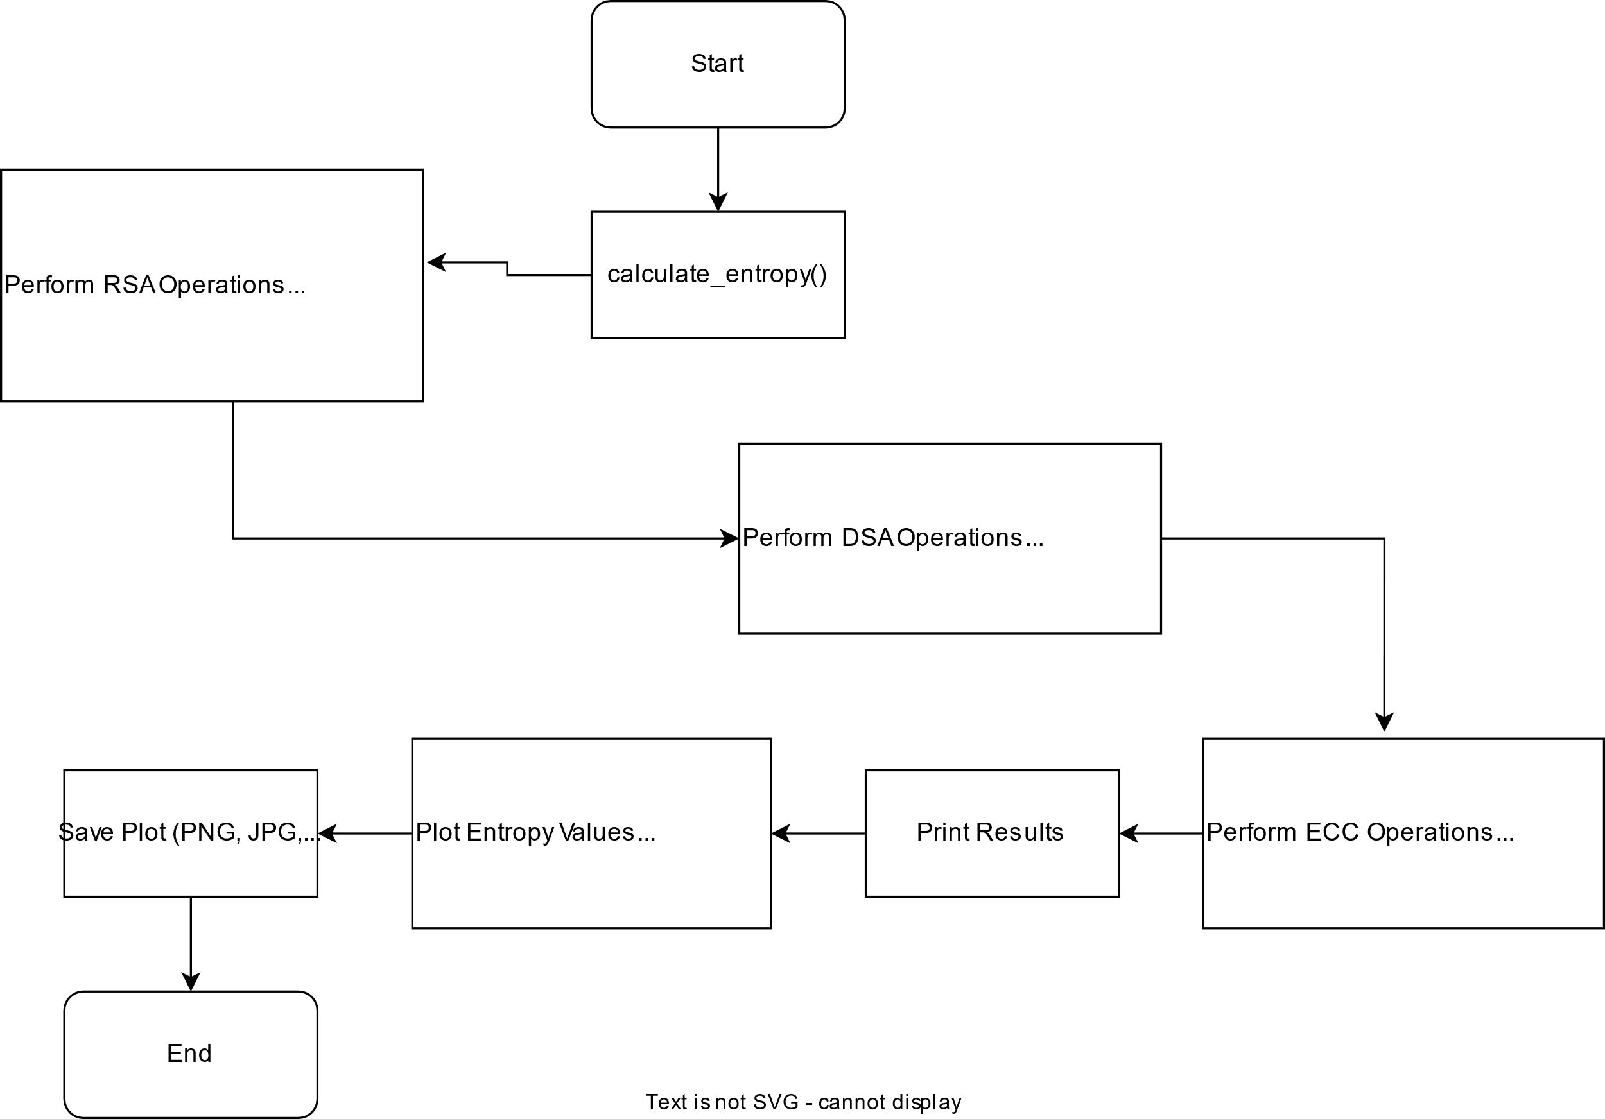

**1. Message Generation (Source)**

* The system starts with the user inputting a plaintext message within a Jupyter Notebook cell.
* This plaintext is treated as a sequence of symbols, each with a defined probability, ensuring randomness in the data structure.
* The message can be manually entered or programmatically generated based on specific use cases.
* The entropy of the plaintext is calculated at this stage to assess its randomness and predictability.

**2. Encryption Process (Cipher System)**

* Once the plaintext is provided, the system applies an encryption algorithm based on Shannon’s principles of **confusion** and **diffusion** to enhance security.
* A secret key, known only to the sender and the receiver, is used to encrypt the message.
* The encryption function scrambles the original message, converting it into an unintelligible ciphertext.
* The randomness and entropy of the ciphertext are analyzed, ensuring that it maintains a high level of security.

**3. Transmission Through a Noisy Channel**

* The encrypted message is then transmitted over a simulated noisy channel, mimicking real-world communication systems.
* In an insecure medium, the system assumes the presence of potential attackers who may attempt to intercept the message.
* To counteract such threats, Shannon’s theorem ensures that even if an attacker captures the ciphertext, it remains computationally infeasible to retrieve the original plaintext without the decryption key.
* The noisy channel may introduce some distortions, which the system accounts for by implementing error detection mechanisms.

**4. Decryption Process at the Receiver’s End**

* At the receiving end, the system applies a decryption function using the same secret key to retrieve the original message.
* The decryption process reverses the encryption steps, reconstructing the plaintext from the ciphertext.
* To verify the accuracy and integrity of the recovered message, error correction techniques may be employed.
* If an incorrect key is used, the decrypted output remains unintelligible, reinforcing the security model.

**5. Security Analysis and Entropy Measurement**

* To assess the robustness of encryption, the system calculates and visualizes Shannon entropy, measuring the uncertainty of the encrypted message.
* A higher entropy value indicates that the encryption is effective, making it harder for attackers to predict or decrypt the message.
* The system also evaluates probability distributions to ensure that the encrypted data does not reveal patterns that could be exploited.
* Graphical tools, such as histograms and entropy plots, help users analyze the security level of their encrypted messages.

This structured approach ensures that the system adheres to Shannon’s **perfect secrecy** principle, making it resistant to brute-force attacks and statistical analysis.

**Working Principle**

The working principle of the system is based on secure information transmission using encryption, decryption, and entropy-based security analysis. The core working process follows these steps:

1. **Message Generation and Input Processing:**

* The user inputs a plaintext message which is the original data intended for secure communication.
* The system preprocesses the message to remove inconsistencies and ensure proper encoding.

1. **Key Generation and Encryption:**

* The system generates a secret key, ensuring high randomness and unpredictability.
* The plaintext is encrypted using symmetric or asymmetric cryptographic methods.
* The entropy of the generated ciphertext is analyzed to measure security effectiveness.

1. **Secure Transmission Through Noisy Channels:**

* The encrypted message is transmitted through a simulated noisy channel.
* The system assumes adversarial presence and tests resistance against interception.

1. **Decryption and Integrity Verification:**

* The receiver decrypts the message using the corresponding secret key.
* The decrypted output is compared with the original plaintext to verify transmission accuracy.

1. **Security Evaluation Using Entropy and Probability Distributions:**

* The randomness of encryption keys and ciphertext is visualized through entropy graphs and histograms.
* Higher entropy values indicate better security, preventing pattern recognition attacks.
* The system performs statistical analysis to identify vulnerabilities in encryption methods.

**Results and Discussion**

1. **Entropy Analysis Results:**
   * The computed entropy values indicate the randomness levels of different encryption algorithms.
   * AES and 3DES exhibit higher entropy, ensuring stronger security, while DES shows lower entropy, making it more vulnerable.
2. **Key Randomness and Probability Distributions:**
   * Histogram analysis confirms that secure key generation leads to an even probability distribution.
   * Weak keys show patterns that could make encryption susceptible to statistical attacks.
3. **Performance Evaluation:**
   * Encryption and decryption speed are analyzed for different algorithms.
   * Results highlight the trade-off between security strength and computational efficiency.
4. **Comparison with Traditional Cryptographic Methods:**
   * The system’s implementation is compared with standard cryptographic practices to assess improvements in security and efficiency.

# Symmetric Algorithms

# 

# Appendix:

# Code:

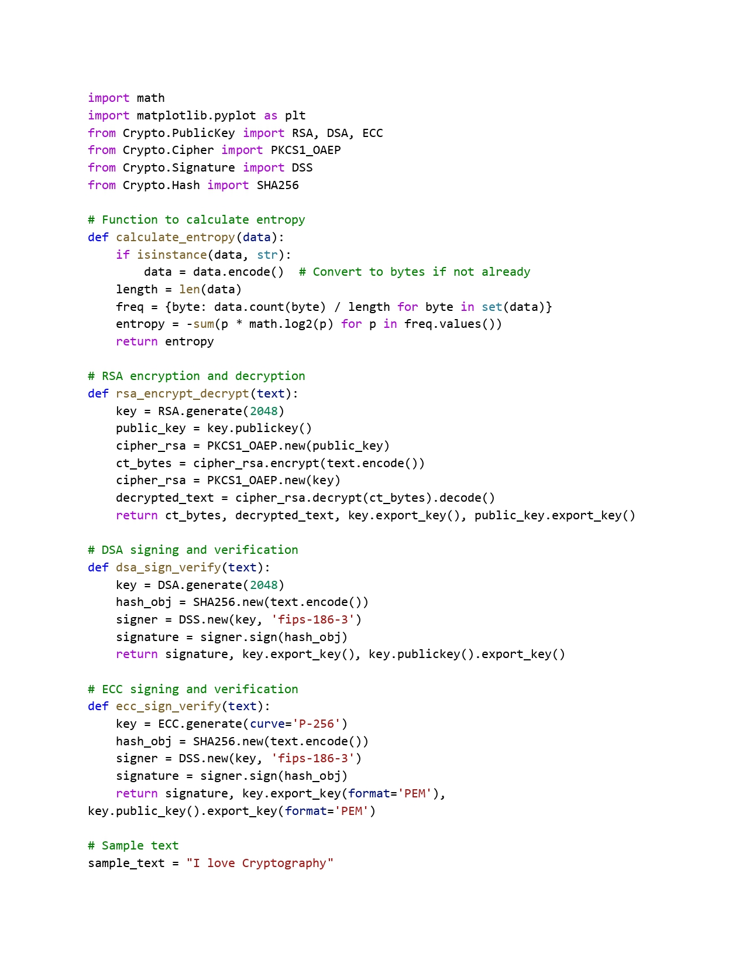

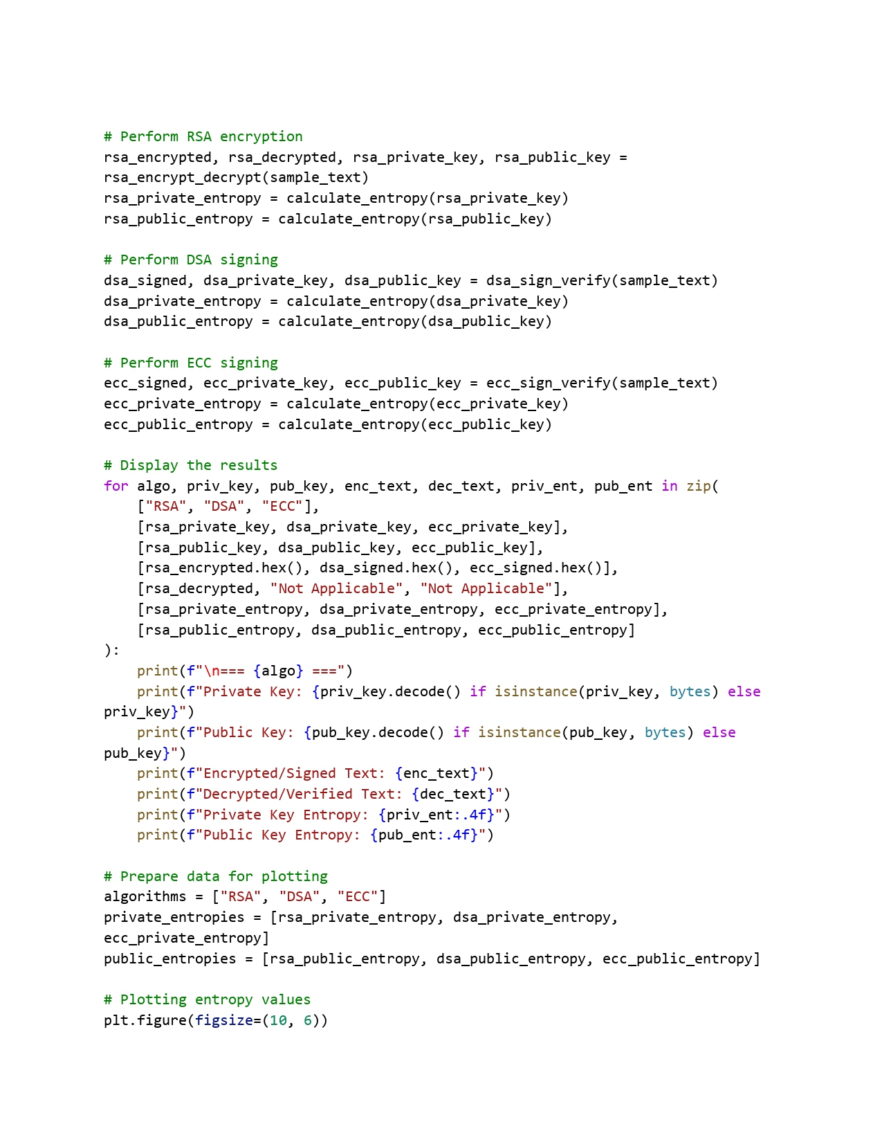

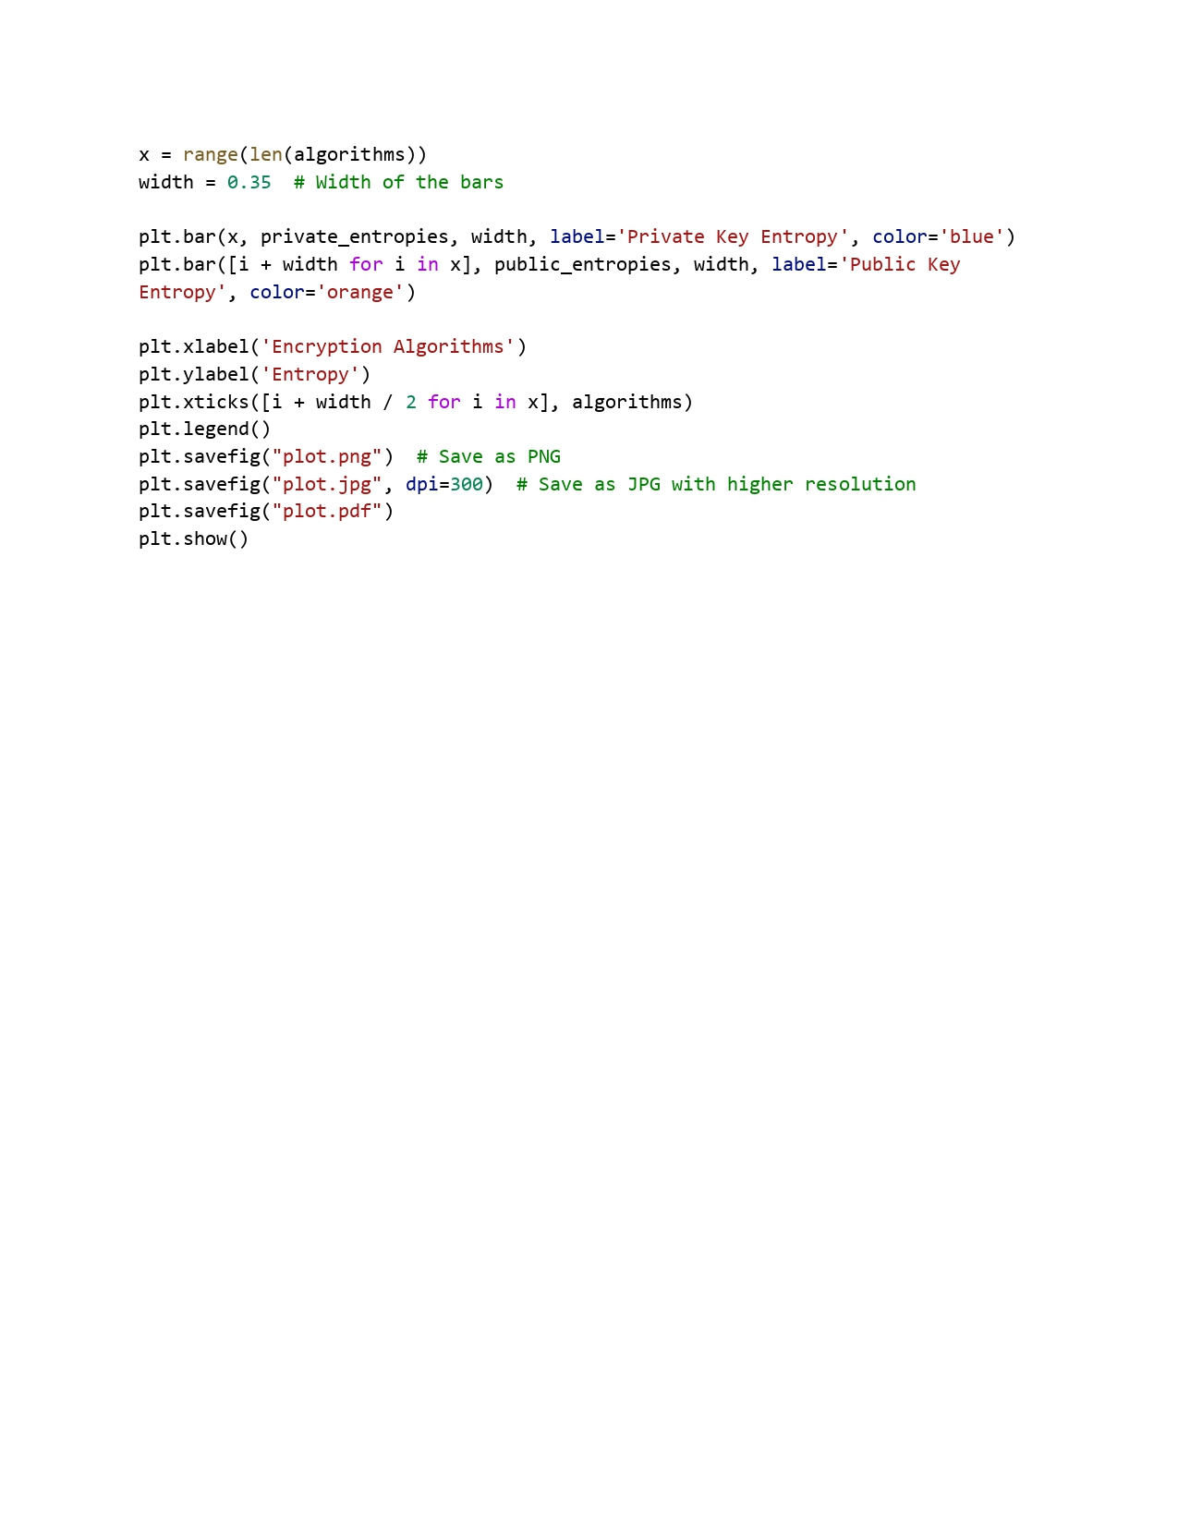

* + - **Asymmetric Algorithms**

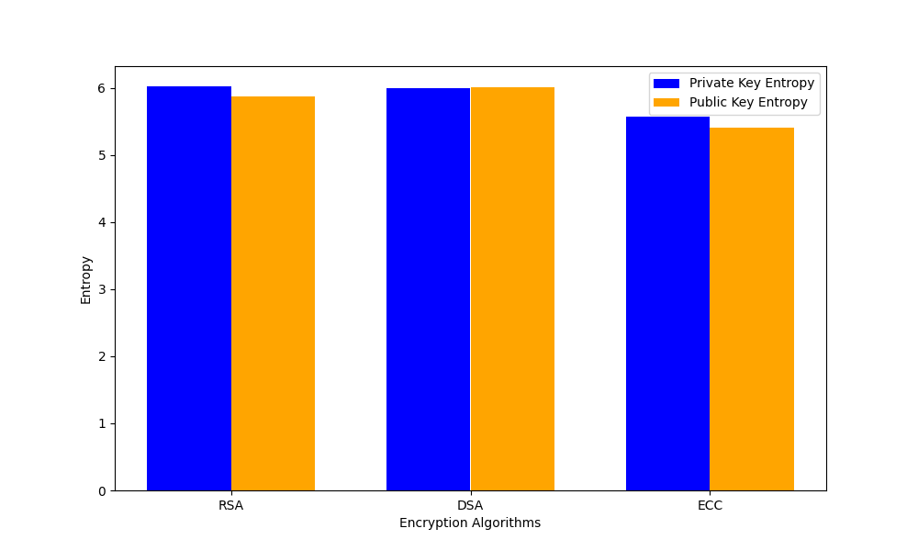

**Code:**

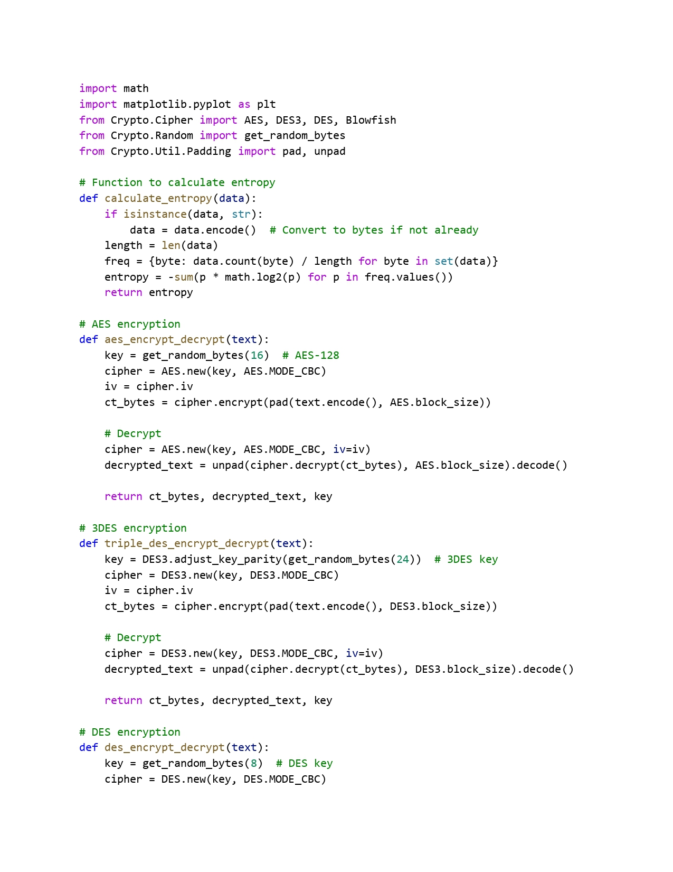

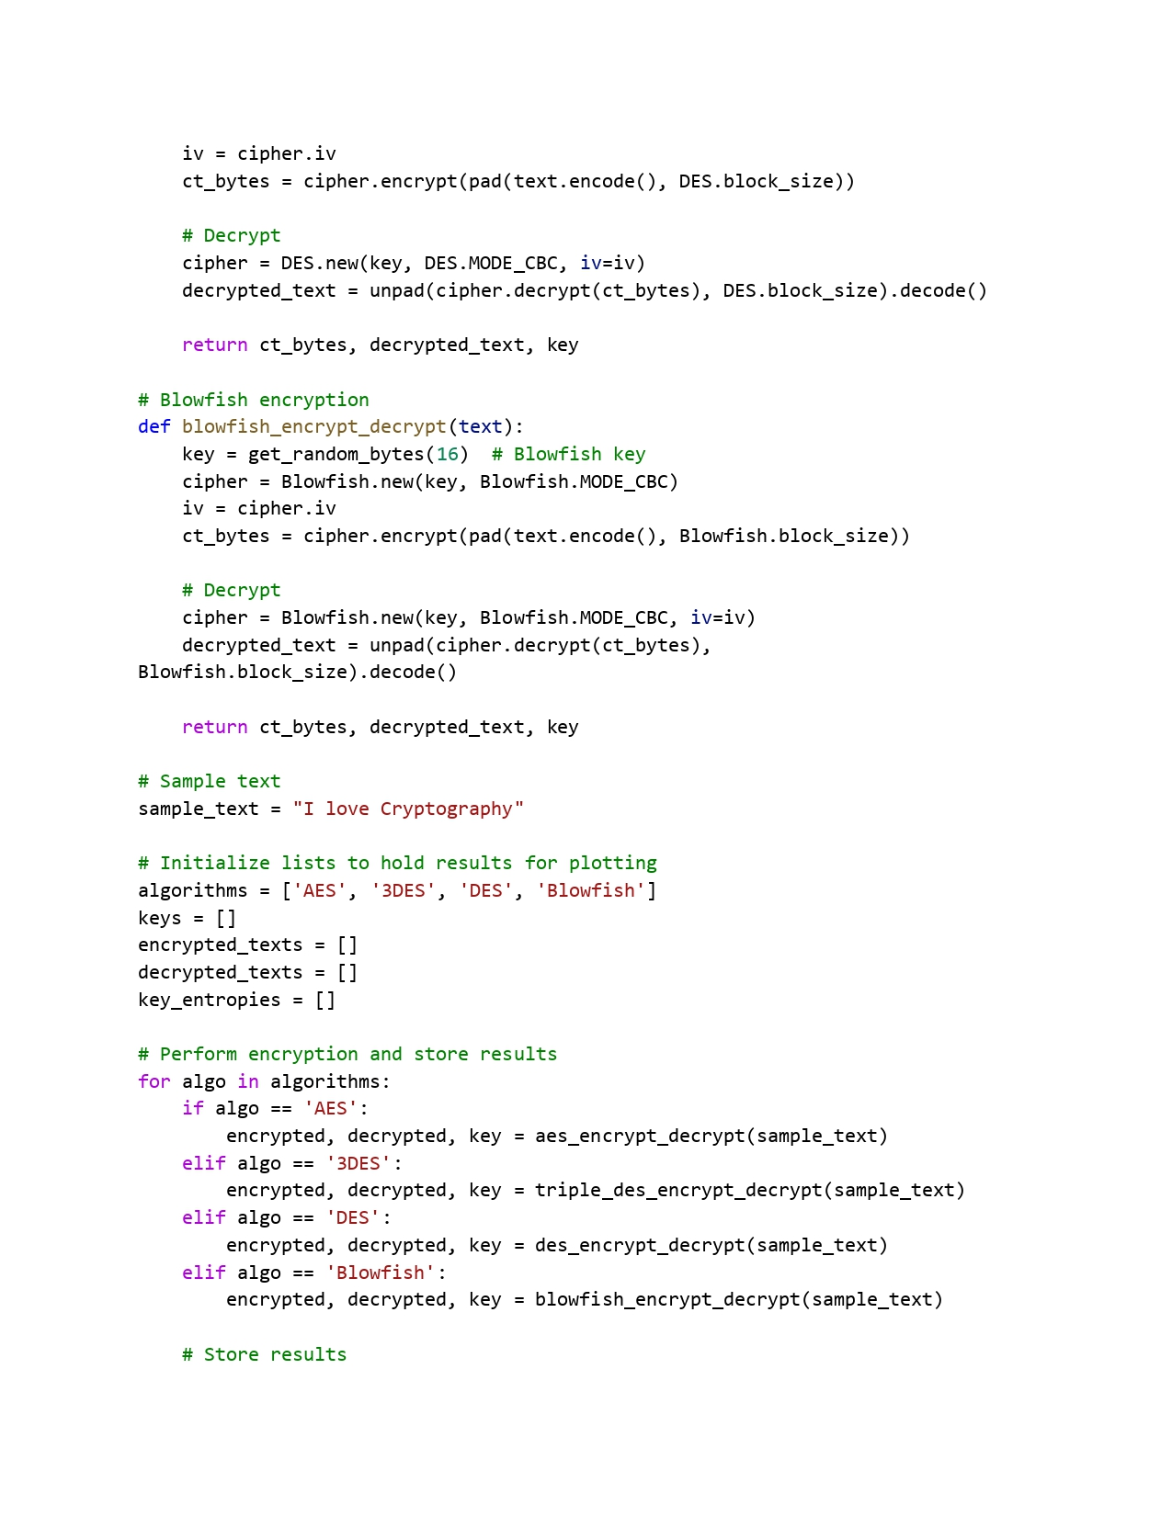

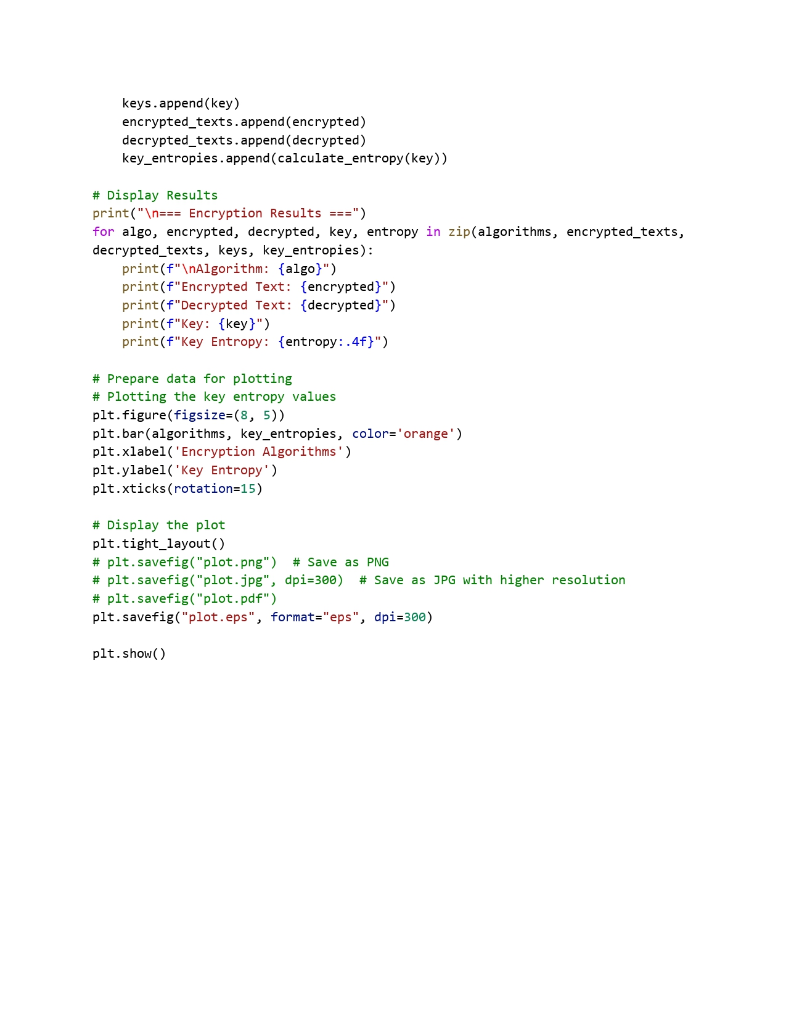

### Individual Contribution:

**Karan Kumar Chauhan (21BCE10243):**

* Responsible for coding and algorithmic analysis aspects of the research.
* Implemented various cryptographic algorithms and analyzed their efficiency in terms of speed, security, and computational complexity.
* Collaborated in writing and testing code for encryption and decryption processes, ensuring their correctness and robustness.

**Abhishek Kumar (21BCE10084)**:

* Responsible for in-depth analysis on the fundamentals of information theory.
* Responsible for gathering information on key concepts such as entropy, mutual information, and channel capacity.
* Contributed in studying various theoretical models that quantify information and its transmission efficiency.

**Deep Radadiya (21BCE11343):**

* Contributed on exploring and analyzing different cryptographic models.
* Provided an in-depth analysis on symmetric and asymmetric encryption techniques, hash functions, and key exchange mechanisms.
* Researched on classical cryptographic methods such as RSA, AES, and ECC, along with emerging trends in quantum-resistant cryptography.

**Vikash Kumar Sinha(21BCE11500):**

* Responsible for analyzing how principles from information theory enhance cryptographic techniques, particularly in the context of secure encoding and transmission.
* Contributed by studying Shannon’s theory of perfect secrecy, error correction codes, and the application of entropy in cryptographic key generation and extracting the important information.
* Contributed by explaining how cryptographic models safeguard information in digital communication systems.

**Amul Gupta(21BCE11606):**

* Responsible for explaining the significance of cryptographic techniques and their interplay with information theory.
* Responsible for literature review and highlighting the existing challenges in cryptographic systems.
* Collaborated in compiling the code and results of various cryptographic algorithms.

# CHAPTER 5: CONCLUSION

# A secure communication system that integrates encryption, decryption, and entropy-based analysis can offer enhanced protection against various cryptographic threats. By applying both symmetric and asymmetric encryption techniques, along with entropy evaluation, it becomes possible to assess the unpredictability and strength of cryptographic keys more effectively.

# Observations indicate that higher entropy values are generally associated with stronger security, as they reduce the risk of successful cryptanalysis. Incorporating Shannon’s model of secure communication provides a theoretical framework to explore how encryption schemes respond under potential attack scenarios, including brute-force methods.

# The comparison of cryptographic algorithms also highlights important trade-offs between computational efficiency and security, suggesting that algorithm selection should be based on the specific requirements of the application environment.

# Overall, the integration of information-theoretic concepts such as entropy into cryptographic analysis reinforces the importance of randomness in key generation and algorithm performance. Continued exploration in this area may lead to more secure and efficient encryption practices, especially as digital communication systems evolve in complexity.

# References and Publications:

1. C. E. Shannon, “A mathematical theory of communication,” The Bell System Technical Journal, vol. 27, pp. 379–423, 623–656, Jul. 1948.
2. S. Alam, S. Thakor, and S. Abbas, “On enumerating distributions for associated vectors in the entropy space,” in Proceedings of the International Symposium on Information Theory and its Applications (ISITA), IEICE, Singapore, Oct. 2018, pp. 65–69.
3. S. Alam, S. Thakor, and S. Abbas, “Inner bounds for the almost entropic region and network code construction,” IEEE Transactions on Communications, vol. 69, no. 1, pp. 19–30, 2021. DOI: 10.1109/TCOMM.2020.3030055.
4. S. Naeem, S. Anam, A. Ali, M. Zubair, and M. M. Ahmed, A brief history of information theory by Claude Shannon in data communication, 8th ed., Basel, Switzerland: MDPI, Jan. 2023, pp. 1–31.
5. K. Sayood, Information theory and cognition: A review. Morgan Claypool Publishers, Sep. 2018, pp. 2–5.
6. S. Dehaene, M. I. Posner, and D. M. Tucker, “Localization of a neural system for error detection and compensation,” NeuroImage, vol. 5, no. 5, Sep. 1994.
7. A. Rapoport and W. J. Horvath, “The theoretical channel capacity of a single neuron as determined by various coding systems,” Information and Control, vol. 3, no. 4, pp. 335–350, Dec. 1960.
8. A. M. Abdullah, “Advanced encryption standard (AES) algorithm to encrypt and decrypt data,” International Journal of Computer Science and Mobile Computing, Jun. 2017.
9. D. Chowdhury, A. Dey, R. Garai, et al., “Decrypt: A 3DES-inspired optimized cryptographic algorithm,” Journal of Ambient Intelligence and Humanized Computing, vol. 14, no. 5, 2023.
10. K. Meera and N. Selvaganesan, “Study on various encryption/decryption algorithms for secure communication using chaotic based hashed key,” in 2023 Ninth Indian Control Conference (ICC), Visakhapatnam, India: IEEE, 2023, pp. 79–84.
11. A. M. Alabaichi, F. Ahmad, and R. Mahmod, “Security analysis of Blowfish algorithm,” International Journal of Computer Science and Mobile Computing, Sep. 2013.
12. F. J. Aufa, Endroyono, and A. Affandi, “Security system analysis in combination method: RSA encryption and digital signature algorithm,” in 2018 4th International Conference on Science and Technology (ICST), Yogyakarta, Indonesia: IEEE, 2018, pp. 1–5.
13. M. R. Ramadhan, S. Mandala, and F. A. Yulianto, “Analysis and implementation of digital signature algorithm in PDF document,” in 2023 11th International Conference on Information and Communication Technology (ICoICT), Melaka, Malaysia: IEEE, 2023, pp. 11–16.
14. M. Gobi, R. Sridevi, and R. R. Priyadharshini, “A comparative study on the performance and the security of RSA and ECC algorithm,” International Journal of Advanced Science and Technology, pp. 168–171, Oct. 2020.
15. U. Maurer, Information-theoretic cryptography. Springer-Verlag Berlin Heidelberg, 1999, pp. 49–62.
16. C. E. Shannon, “Communication theory of secrecy systems,” Bell System Technical Journal, vol. 28, pp. 656–715, Oct. 1949.
17. U. Maurer, “The strong secret key rate of discrete random triples,” in Lecture Notes in Computer Science, Springer, 1994, pp. 271–285.
18. K. S. McCurley and C. D. Ziegler, Advances in cryptology (Lecture Notes in Computer Science). Springer, 1998, vol. 1440.
19. A. D. Wyner, “The wire-tap channel,” Bell System Technical Journal, Oct. 1975.
20. I. Csiszar and J. Korner, “Broadcast channels with confidential messages,” IEEE Transactions on Information Theory, vol. 24, no. 3, pp. 339–348, May 1978.
21. U. M. Maurer, “Secret key agreement by public discussion from common information,” IEEE Transactions on Information Theory, vol. 39, no. 3, pp. 733–742, May 1993.